Financial Engineering Lab 1

Question 1

M Call Option Price
1 38.167635
5 34.906533
10 33.625022
20 33.859449
50 33.981184
100 34.011161
200 34.019579
400 34.019132
M Put Option Price
1 19.941717
5 16.680615
10 15.399104
20 15.633532
50 15.755267
100 15.785243
200 15.793661
400 15.793214

Question 2
For Step Size 1
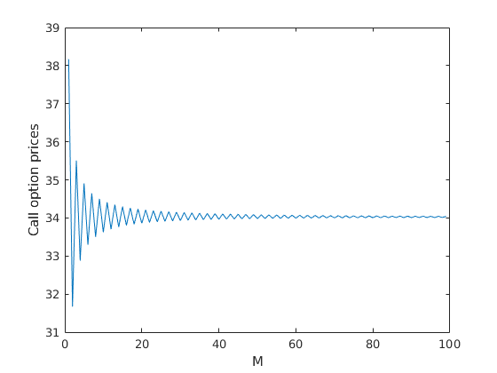
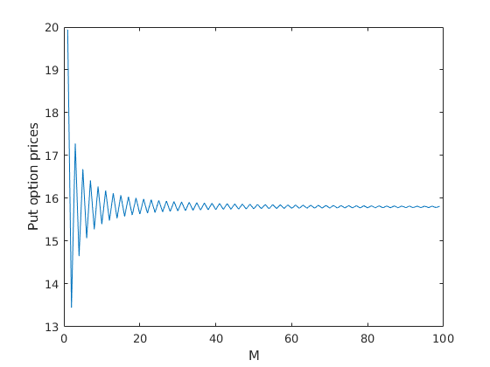

For Step Size 5
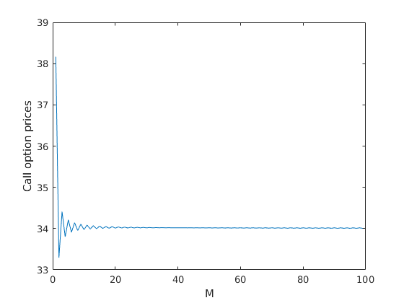
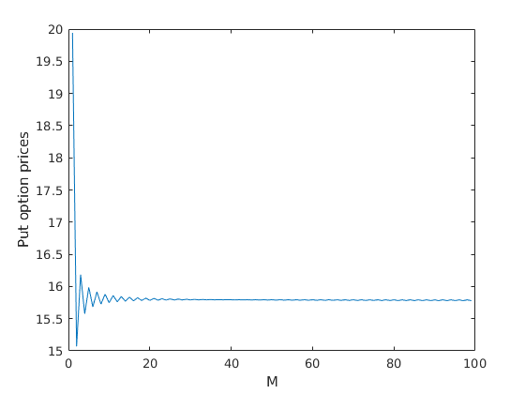

Question 3
At t=0.000000 call values are
33.8594
At t=0.000000 put values are
15.6335

At t=0.500000 call values are
15.0959 31.8933 59.9588

At t=0.500000 put values are
24.6728 15.4871 8.4792

At t=1.000000 call values are
5.1548 13.4697 29.8040 57.7000 100.6627

At t=1.000000 put values are
35.9653 24.9833 15.2694 8.0042 3.5042

At t=1.500000 call values are
1.1250 4.1214 11.7675 27.5732 55.2954 98.4389 160.6114

At t=1.500000 put values are
48.3050 36.9701 25.2710 14.9634 7.4363 2.9982 0.9424

At t=3.000000 call values are

0 0 0 0.1183 1.2360 6.1485 19.7252 46.9762 91.1934 154.8417 242.0302 359.9342 519.0997

At t=3.000000 put values are

78.2282 72.3577 64.4333 53.8548 40.5333 25.9550 13.2218 4.9582 1.2357 0.1721 0.0087 0 0

At t=4.500000 call values are
1.0e+03 *

Columns 1 through 10

0 0 0 0 0 0 0 0 0 0.0081

Columns 11 through 19

0.0363 0.0840 0.1491 0.2372 0.3560 0.5163 0.7328 1.0250 1.4194

At t=4.500000 put values are
Columns 1 through 10

95.5341 93.1293 89.8832 85.5015 79.5868 71.6028 60.8254 46.2776 26.6400 8.2812

Columns 11 through 19

0.6015 0 0 0 0 0 0 0 0

